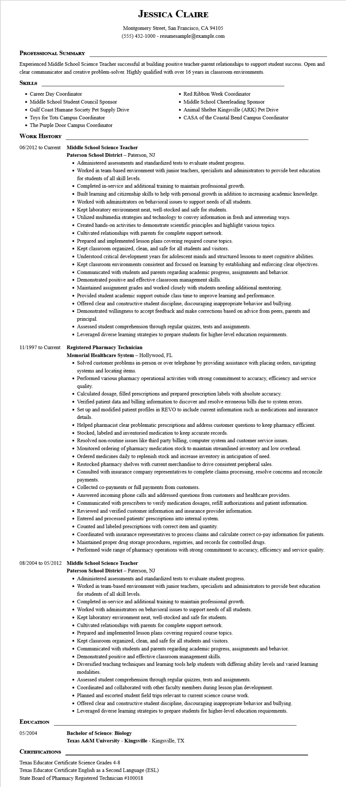
JESSICA CLAIRE
Montgomery Street, San Francisco, CA 94105
(555) 432-1000 - resumesample@example.com
PROFESSIONAL SUMMARY
Experienced Middle School Science Teacher successful at building positive teacher-parent relationships to support student success. Open and clear communicator and creative problem-solver. Highly qualified with over 16 years in classroom environments.
SKILLS
• Career Day Coordinator
• Middle School Student Council Sponsor
• Gulf Coast Humane Society Pet Supply Drive Toys for Tots Campus Coordinator
• The Purple Door Campus Coordinator
WORK HISTORY
06/2012 to Current Middle School Science Teacher
Paterson School District - Paterson, NJ
• Red Ribbon Week Coordinator
• Middle School Cheerleading Sponsor
• Animal Shelter Kingsville (ARK) Pet Drive
• CASA of the Coastal Bend Campus Coordinator
• Administered assessments and standardized tests to evaluate student progress.
• Worked in team-based environment with junior teachers, specialists and administrators to provide best education for students of all skill levels.
• Completed in-service and additional training to maintain professional growth.
• Built learning and citizenship skills to help with personal growth in addition to increasing academic knowledge.
• Worked with administrators on behavioral issues to support needs of all students.
• Kept laboratory environment neat, well-stocked and safe for students.
• Utilized multimedia strategies and technology to convey information in fresh and interesting ways.
• Created hands-on activities to demonstrate scientific principles and highlight various topics.
• Cultivated relationships with parents for complete support network.
• Prepared and implemented lesson plans covering required course topics.
• Kept classroom organized, clean, and safe for all students and visitors.
• Understood critical development years for adolescent minds and structured lessons to meet cognitive abilities.
• Kept classroom environments consistent and focused on learning by establishing and enforcing clear objectives.
• Communicated with students and parents regarding academic progress, assignments and behavior.
• Demonstrated positive and effective classroom management skills.
• Maintained assignment grades and worked closely with students needing additional mentoring.
• Provided student academic support outside class time to improve learning and performance.
• Offered clear and constructive student discipline, discouraging inappropriate behavior and bullying.
• Demonstrated willingness to accept feedback and make corrections based on advice from peers, parents and principal
• Assessed student comprehension through regular quizzes, tests and assignments.
• Leveraged diverse learning strategies to prepare students for higher-level education requirements.
11/1997 to Current Registered Pharmacy Technician
Memorial Healthcare System - Hollywood, FL
• Solved customer problems in-person or over telephone by providing assistance with placing orders, navigating systems and locating items.
• Performed various pharmacy operational activities with strong commitment to accuracy, efficiency and service quality.
• Calculated dosage, filled prescriptions and prepared prescription labels with absolute accuracy.
• Verified patient data and billing information to discover and resolve erroneous bills due to system errors.
• Set up and modified patient profiles in REVO to include current information such as medications and insurance details.
• Helped pharmacist clear problematic prescriptions and address customer questions to keep pharmacy efficient.
• Stocked, labeled and inventoried medication to keep accurate records.
• Resolved non-routine issues like third party billing, computer system and customer service issues.
• Monitored ordering of pharmacy medication stock to maintain streamlined inventory and low overhead.
• Ordered medicines daily to replenish stock and increase inventory in anticipation of need.
• Restocked pharmacy shelves with current merchandise to drive consistent peripheral sales.
• Consulted with insurance company representatives to complete claims processing, resolve concerns and reconcile payments.
• Collected co-payments or full payments from customers.
• Answered incoming phone calls and addressed questions from customers and healthcare providers.
• Communicated with prescribers to verify medication dosages, refill authorizations and patient information.
• Reviewed and verified customer information and insurance provider information.
• Entered and processed patients' prescriptions into internal system.
• Counted and labeled prescriptions with correct item and quantity.
• Coordinated with insurance representatives to process claims and calculate correct co-pay information for patients.
• Maintained proper drug storage procedures, registries, and records for controlled drugs.
• Performed wide range of pharmacy operations with strong commitment to accuracy, efficiency and service quality.
08/2004 to 05/2012 Middle School Science Teacher
EDUCATION
05/2004
CERTIFICATIONS
Paterson School District - Paterson, NJ
• Administered assessments and standardized tests to evaluate student progress.
• Worked in team-based environment with junior teachers, specialists and administrators to provide best education for students of all skill levels.
• Completed in-service and additional training to maintain professional growth.
• Worked with administrators on behavioral issues to support needs of all students.
• Kept laboratory environment neat, well-stocked and safe for students.
• Cultivated relationships with parents for complete support network.
• Prepared and implemented lesson plans covering required course topics.
• Kept classroom organized, clean, and safe for all students and visitors.
• Communicated with students and parents regarding academic progress, assignments and behavior.
• Demonstrated positive and effective classroom management skills.
• Diversified teaching techniques and learning tools help students with differing ability levels and varied learning modalities.
• Assessed student comprehension through regular quizzes, tests and assignments.
• Coordinated and collaborated with other faculty members during lesson plan development.
• Planned and escorted student field trips relevant to current science course work.
• Offered clear and constructive student discipline, discouraging inappropriate behavior and bullying.
• Leveraged diverse learning strategies to prepare students for higher-level education requirements.
Bachelor of Science: Biology
Texas A&M University - Kingsville - Kingsville, TX
Texas Educator Certificate Science Grades 4-8
Texas Educator Certificate English as a Second Language (ESL)
State Board of Pharmacy Registered Technician #100018

